Vielen Dank, dass du dir unsere CV-Vorlage heruntergeladen hast! Bei den einzelnen Stationen im Lebenslauf handelt es sich um Mustertexte, weshalb du die Vorlage mit deinen eigenen Informationen füllen und den Lebenslauf für deine Bewerbung individualisieren solltest.

Lösche dazu diese Seite aus diesem Dokument und ergänze den Lebenslauf mit deinen persönlichen Daten. Die Seite kannst du ganz einfach löschen, indem du alle Inhalte auf dieser Seite markierst und die Entfernen-Taste („Entf“) drückst.

Du möchtest deine Bewerbung doch lieber professionell erstellen lassen? Wir empfehlen:

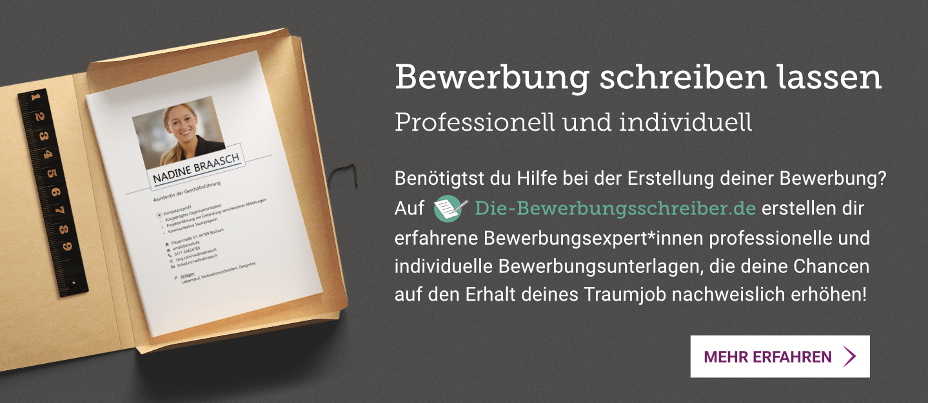
www.die-bewerbungsschreiber.de

Curriculum Vitae

Personal Profile
Experienced Sales Manager. Highly motivated, creative and adaptive with high sense of responsibility. Goal oriented team player with great communication skills. Offering strong leading skills as well as very good analytical skills. At Beispiel GmbH, cut costs by 13% in 6 months by implementing Lean training.

Areas of Expertise
- Customer Care | - Relationship Building | - Presentation & Proposals
- Sales Team Supervision | - Marketing Strategies | - Negotiation Management
- Project Management | - Lead Qualifications | - New Product Launch

Work Experience

since 02/2019 Head of the Sales Team
Beispielunternehmen, Beispielstadt in Land
- Responsibility for 4 team leaders and a total of 35 employees
- Conceptualizing, setting up, launching and monitoring of strategic sales campaigns
- Developing marketing plans
- Negotiating costs and placement with customers
- Customer service

11/2007 – 12/2009 Sales Manager
Musterfirma, Musterstadt in Land
- Establishing cost-efficient and customer-friendly sales solutions
- Conceptualizing and launching of a mobile application to the market
- Coordinating and managing projects as subject leader
- Preparing project concepts

Internships
02/2014 – 05/2014 Sales und Marketing Intern
Exampleunternehmen, Beispielstadt in Land
- Managing existing customers in responding to their requests, developing and maintaining the network
- Assisting in acquiring new customers by analysing possible future customers
- Provide assistance with event planning to increase product awareness

06/2012 – 10/2012 Business Development Intern
Beispielunternehmen, Examplestadt in Land
- Working on various projects, including working with database applications to generate reports
- Creating presentations to visualize the findings of data analyses

Education
05/2013 – 04/2015 Master of Science in Management
University of Examplestadt in Land
Thesis: Beispiel-Thema

05/2010 – 04/2013 Bachelor of Science in General Management
University of Applied Sciences, Musterstadt in Land

Additional Skills & Qualifications
Languages German, native speaker
English, business fluent written and spoken

Computer skills Microsoft Office (Word, Excel, PowerPoint, Outlook), advanced
HTML, basic knowledge

Drivers license European Type B

Seminars HTML basic course
Hosting & Presentation skills

References
Maria Musterfrau Supervisor
Sales Manager Mrs. Mustermann supervised my work at
Beispielunternehmen Beispielunternehmen and supported my
1234 Beispielstraße career during many years of service…
12345 Beispielstadt
Office: 0123 4578
maria.musterfrau@beispiel.de

Prof. Dr. Max Beispiel Academic Advisor
University Professor Prof. Beispiel was a valuable contact and
University of Examplestadt guardian during the completion of my master’s
1234 Examplestraße thesis.
12345 Examplestadt
Office: 0123 456789
mx.beispiel@uniexamplestadt.de

