Beispieluniversität
Name Nachname
123 Straße
12345 Stadt
Musterstadt, 13.06.2022
Letter of Motivation

Dear Sir or Madam
In my five semesters of the International Business program at the University of Applied Sciences Muster and my training as an Industrial Clerk, I have already been able to gain valuable experience in the areas of "international marketing" and "sales management". I would like to deepen this theoretical and partly practical knowledge at your university. In addition, to broaden my intercultural skills and improve my English proficiency, I am eager to spend the upcoming summer semester at Muster University.
During my previous studies and my internship in the internationally active company Muster GmbH, I was able to make first contacts with customers and suppliers from Musterland. My distinct ability to learn, my high affinity for languages, and my flexibility were especially helpful. Since I am very interested in international trade and see my future in a company that operates at international level, I would like to further improve my intercultural skills at your university with a semester abroad.
I chose the Business School in Musterstadt because it offers a wide range of scientific and financial subjects. What motivates me to spend a semester in Musterstadt is the chance to apply my knowledge during class and to get to know the culture while staying in Musterland.
My strong ambition and determination are two of my personal strengths. Even at a young age, I was aware of my goals and have independently achieved above-average results. This resulted in very good grades, both in school and at university. In addition, I see myself as an open, versatile, and self-confident person who strives to continuously improve and expand his skills and knowledge.
I am a communicative student that speaks English fluently. The semester abroad at your university is the next step on my way to becoming a successful Business Manager. I would be honoured to spend the next winter semester at the University of Muster.

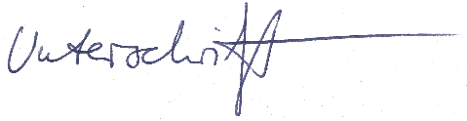
Yours sincerely

Max Muster
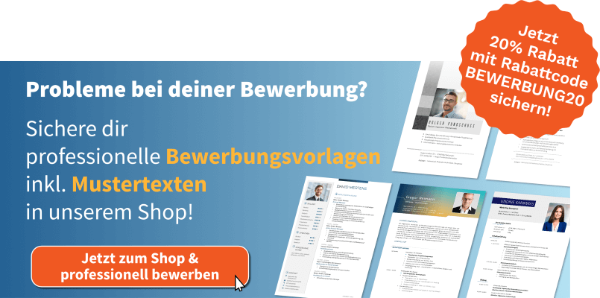
shop.bewerbung.net

