Vielen Dank, dass du dir unsere Anschreiben-Vorlage heruntergeladen hast! Es handelt sich hierbei um einen Mustertext, welchen du, um ihn zu verwenden, individualisieren und inhaltlich anpassen solltest.

Lösche dazu diese Seite aus diesem Dokument und ergänze das Anschreiben mit deinen persönlichen Informationen. Die Seite kannst du ganz einfach löschen, indem du alle Inhalte auf dieser Seite markierst und die Entfernen-Taste („Entf“) drückst.

Du möchtest deine Bewerbung doch lieber professionell erstellen lassen? Wir empfehlen:

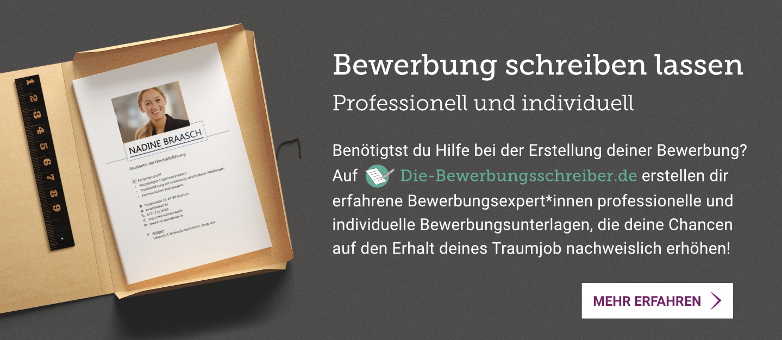
www.die-bewerbungsschreiber.de

Good Employer Inc.
Mr. John Doe
123 Main Street
12345 Springfield

Musterstadt, 11.01.2023

Application as Production Manager
Job ID 123456

Dear Mr. Doe

As a pro-active management expert with 20 years of professional experience, I am now in search of a new challenge that allows me to realize my full potential. A position as Production Manager at Good Employer Inc. offers me the opportunity to utilize my complete expertise. Joining an innovative company that I have come to know as a trustworthy employer with high standards in sustainable production processes truly motivates me.

Most recently I was employed as Team Leader at Not So Good Employer Corp., where I created and implemented new standards in customer service and was responsible for technical support along the entire production chain. Working closely with various manufacturers, suppliers and global trade partners, I have accumulated a lot of experience in the production industry, which includes planning, coordinating and supervising production safety, as well as technical support and quality standards. I deeply understand all aspects and complexities required for an effective production management.

As far as my personal attributes are concerned, my flexibility and quick perception allow for an easy adaption to new tasks and work environments. Always looking for ways to improve and gain a competitive edge, I am motivated to bring new ideas and processes into reality. You may also assume native German and even advanced knowledge of the French language.

Exceedingly motivated, I look forward to the chance to support your company. Thank you very much for taking the time to review my application. In order to convince you of my capabilities, I would welcome the opportunity of a personal interview!

Kind regards
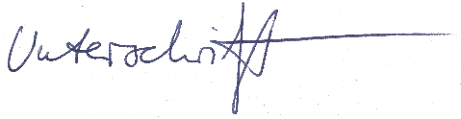

Fanny Knödel

