Maria Mustermann
Musterstraße 123
12345 Musterstadt maria@mustermann.de
0171 23456789
Good Employer Inc.
Mr. John Doe
123 Main Street
12345 Springfield

Musterstadt, xx.xx.20xx

Application as Production Manager

Dear Mr. Doe

As a pro-active management expert with 20 years of professional experience, I am now in search of a new challenge that allows me to realize my full potential. A position as Production Manager at Good Employer Inc. offers me the opportunity to utilize my complete expertise. Joining an innovative company that I have come to know as a trustworthy employer with high standards in sustainable production processes truly motivates me.

Most recently I was employed as Team Leader at Not So Good Employer Corp., where I created and implemented new standards in customer service and was responsible for technical support along the entire production chain. Working closely with various manufacturers, suppliers and global trade partners, I have accumulated a lot of experience in the production industry, which includes planning, coordinating and supervising production safety, as well as technical support and quality standards. I deeply understand all aspects and complexities required for an effective production management.

As far as my personal attributes are concerned, my flexibility and quick perception allow for an easy adaption to new tasks and work environments. Always looking for ways to improve and gain a competitive edge, I am motivated to bring new ideas and processes into reality. You may also assume native German and even advanced knowledge of the French language.

Exceedingly motivated, I look forward to the chance to support your company. Thank you very much for taking the time to review my application. In order to convince you of my capabilities, I would welcome the opportunity of a personal interview!

Kind regards
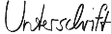

Maria Mustermann

Probleme bei der Bewerbung? Wir empfehlen:

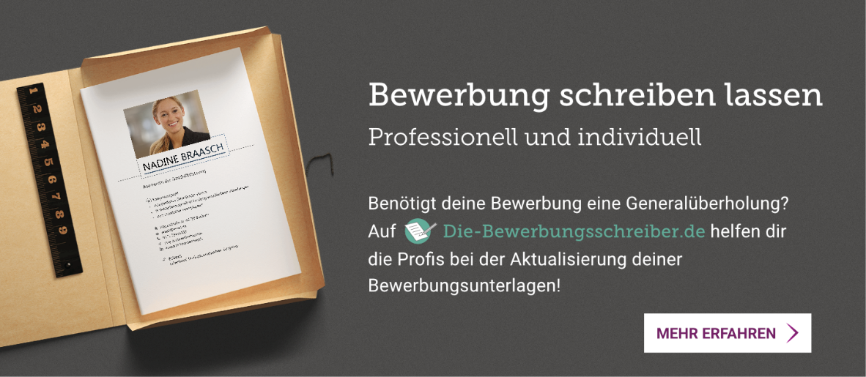
www.die-bewerbungsschreiber.de

